ROLL NO:

NAME:

CY6151 – ENGINEERING CHEMISTRY I

UNIT – 1 POLYMER SCIENCE

LECTURE PLAN

1.1-A) Polymerization – Introduction .
1.1-B) Functionality – Definition – Significance
1.1-C) Tacticity – Isotactic, Syndiotactic and atactic.

1.2) Classification of Polymers.

1.3) Plastics – Advantages and disadvantages – Thermoplastics and
thermosetting plastics.

1.4) Types of polymerization – Addition, Condensation, Co-polymerisation.

1.5-A) Free radical mechanism
1.5-B) Anionic mechanism
1.5-C) Cationic mechanism

1.6) Glass transition temperature – T_{g} – Definition – Factors- significance.

1.7) Molecular weight of polymers –Number average (_{n}) and Weight average(_{w}) molecular weight – Polydispersity index. (_{w} / _{n} )

1.8) Techniques of Polymerisation – Bulk, Solution, Emulsion, Suspension.

1.9) Preparation, properties and uses of Nylon 6,6.

1.10) Preparation, properties and uses of Epoxy resins.

CY6151/ Engineering chemistry-1/ Unit – 1- Polymer Chemistry

1.1)A) POLYMERISATION - INTRODUCTION

1). Under the proper conditions of temperature, pressure and catalyst , the micro (Smaller) molecules are combining together to form a macro (big) molecule. This process is called Polymerisation. Micro molecules are called ‘Monomer’. Macro molecule is ‘Polymer’.

n CH₂ = CH H₂O₂ CH₂ CH
│ │
Cl Polymerisation Cl _{n}

Vinyl Chloride PVC
Monomer polymer
_______________________________________________________________________

2). Requirements of a monomer: a) multiple bonds or b) reactive functional groups.
_____________________________________________________________________

3). The number of monomers present in a polymer is ‘ Degree of polymerisation’ (n).

Degree of Polymerisation = Mol. Wt of polymer
Mol. Wt of monomer

If n = low , Mol.Wt = 500 – 5000 Dalton units, it is Oligo polymer.
If n = High, Mol.Wt = 10,000 – 2,00,000 Dalton units , it is High polymer.
_____________________________________________________________________

4). If the polymer chain contains same type of monomer, it is “ Homo polymer”.
structure: A – A – A- A- A-A –A
e.g PVC

If the polymer chain contains different type of monomer, it is “Hetero polymer”.(or) “Co polymer”.
Structure: A-B- A-A-A-B-A
e.g Nylon
_____________________________________________________________________
5) If the main chain of a polymer is made up of same species of atoms, the polymer is known as homochain polymer.
Structure: C –C- C – C- C
Examples: Polyethylene, polyvinyl chloride

If the main chain of a polymer is made up of different species of atoms, the polymer is known as heterochain polymer.
Structure:C- C -C -O –C- O
Examples: Terylene, Nylon 6,6.
------------------------------------------------------------------------------------------------------------

1.1-B)FUNCTIONALITY:

The number of bonding or reactive sites present in a monomer is called ‘ Functionality’.

Examples:-
CH₂ = CH₂ , The double bond is acting as two reactive site, So, Ethylene functionality is 2.

CH₂ – OH In glycerol three –OH groups present. So, functionality = 3
│
CH – OH
│
CH₂ – OH

Significance of functionality:

1.Substances having only one bonding or reactive site are called “monofunctional
monomers”. Eg. CH₃ – COOH .

They cannot undergo polymerization.

2. If F = 2, they form linear chain structure. (eg) Ethylene
Because of the weak Vander Waal’s attraction, there is no restriction for the movement of one polymer chain over another chain. They have less strength, low heat resistance, softness and flexibility.

3. If F=3, they form branched structure. (Eg) Glycerol
Because of the strong covelent bond, the movement polymer chain is restricted. They have high strength, high heat resistance, hardness .
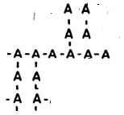

4. If F≥ 4, then they form complexed 3D structure.

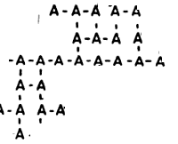

1.1-C) TACTICITY:

Orientation of monomers in a polymer chain is called “Tacticity”.

There are three types of tacticity.

a) Isotactic polymers
b) Atactic polymers
c) Syndiotactic polymers

i) Isotactic :
If the functional groups are in same orientation, it is isotactic.

ii) Atactic:
If the functional groups are arranged randomly it is “atactic”.

iii) Syndiodactic:
If the functional groups are arranged in alternative fashion, it is syndiotactic.

Representation of Tacticity:

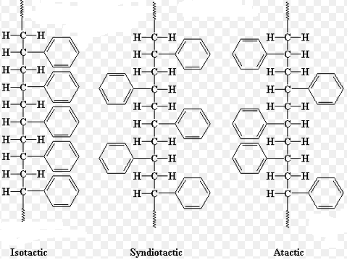

Examples:

Isotatic polymer: Cis-isoprene
Syndiotactic polymer: Trans-isoprene
Atactic polymer: Polypropylene

1.2) CLASSIFICATION OF THE POLYMERS:

A) On the basis of their occurrence:
Natural polymers: Cellulose; Starch; Natural rubber.
Synthetic polymers: Polyethylene; PVC: Bakelite.

B) On the basis of monomeric unit in the backbone of polymers:
Organic polymers: Backbone contains only C-atoms PolyEthylen, PVC.
Inorganic polymers: Backbone contains atoms like O, N, S other than carbon (Silicones, Phosphazine).

C) On the basis of their structure and end use :
Elastomers: Natural rubber; Buna-S; Butyl rubber.
Fibers: Wood; Silk; Cotton-Natural fibers; Terylene-Synthetic fibers.
Plastics: PE, PVC-Thermoplastics; Bakelite-Thermosetting plastics

D) Based on the chemical structure:

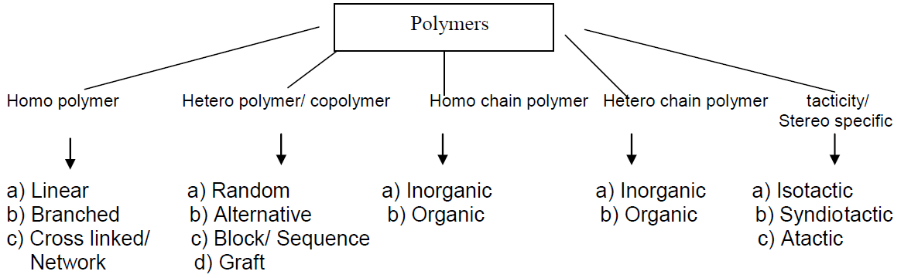

Types of Copolymers:

i) Alternating copolymer:
The different kind of monomers are arranged in alternate manner .
Structure: -M1-M2-M1-M2-M1-M2

ii) Random copolymer:
The different kind of monomers are arranged randomly
Structure: M1-M2-M2-M1-M2-M1

iii) Block copolymer:
A group of monomers arranged continuously is known as block. If one block of monomers are followed by another kind of monomer block, it is block copolymer.
Structure: M1-M1-M1-M2-M2-M2- M1-M1-M1-M2-M2-M2

iv) Graft copolymer:
One kind of monomers are arranged linearly while the other kind of monomers are arranged in branched manner.
Structure:
M1-M1-M1-M1-M1-M1
l
M2
l
M2

1.3)PLASTICS

Definition: Plastics are high polymers which can be moulded into any desired shape under proper conditions of temperature , pressure and catalyst. (e.g) PVC , PET
They are made up of resins, fillers, plasticizers, lubricants etc.,

Advantages of plastics: Disadvantages of low quality plastics:
1. Insulator 1. very soft
2. Corrosion resistant 2. Embrittlement
3. Easy mouldability 3. Agening ( Low durability)
4. Used as shock absorbers 4. Cannot withstand high temperatures.
5. Has adhesive property 5. Creep (shape Deformation due to load)
6. Less weight
7. Chemical inertness
8. Available in various colours

Differences between Thermoplastics and thermosetting plastics
No | THERMOPLASTICS | THERMOSETTING PLASTIC
1 | Eg. PVC , Polyethylene | Polyester, Bakelite
2 | Plastics which are melted at high temperature, solidified at low temperature They can be remelted and remoulded into any desired shapes for any number of times. | They cannot be remoulded after their first usage.
3 | Scrap can be used again. | Scrap can not be used again.
4 | Formed by addition polymerisation | Formed by condensation polymerisation
5 | They have linear structure  M – M – M – M – M – M | They have complex 3D structure.  - M - M - M - M –M  │ │ │ │ │  M -M - M - M - M  │ │ │ │ │  M - M - M – M – M  │ │ │ │ │
6 | The bond strength is low | The bond strength is high
7 | Molecular weight is low | Molecular weight is high
8 | Soluble in organic solvents. | Insoluble in organic solvents.
9 | Prepared by Injection moulding | Prepared by compression moulding.

1.4) TYPES OF POLYMERISATION :
1. Addition 2. Condensation 3. Copolymerisation
No | Addition Polymerisation | Condensation Polymerisation
1 | Eg. PVC | Eg. Nylon 6,6
2 | Otherwise known as “Chain growth Polymerisation”. | Otherwise known as “Step wise Polymerisation”.
3 | Monomers are adding together to form polymers. | Monomers are condensed to form polymer.
4 | No elimination of other molecules. | Elimination of smaller molecules occur.
5 | At least one multiple bond presence is essential condition. | Monomers must have two or more functional groups.
6 | Homo polymers are formed. | Hetero polymers are formed.
7 | Thermoplastics are formed. | Thermo set plastics are formed.
8 | Molecular weight of the polymer is the integral multiple of monomers. | Need not be so.
9 | Monomers disappear slow and steadily. | Monomers disappear at the initial stage of the reaction.
10 | Longer processing time is needed to increase yield. | Longer time is essential for increasing molecular weight.

Addition Polymerisation:
Monomers having multiple bonds (double or triple bond) undergo addition polymerization. Monomers combine to give polymer through addition reaction without elimination of any smaller molecules.
CH₂ = CH H₂O₂ CH₂ CH
│ │
Cl Polymerisation Cl _{n}

Vinyl Chloride PVC

Condensation Polymerisation:
Monomers having same or different types of functional groups undergo condensation polymerization. The polymerization proceeds by step wise reaction between reactive functional groups and small molecules are eliminated.

Co-Polymerisation:
1. It is a special kind of polymerisation, otherwise known as “Joint polymerisation”.
The product is known as ‘Co-polymers’. This is superior to other polymerization because It is used to alter the hardness, strength, rigidity and crystallinity of the monomers.
e.g SBR synthesis CH₂ = CH
│
n CH₂ = CH - CH = CH₂ + n C₆H₅ →
( 75% butadiene) (25% Styrene)

[ CH₂ - CH = CH - CH₂ - CH₂ - CH -]_{n}
│
C₆H₅ (Styrene – Butadiene RubberSBR)

1.5-A)MECHANISM OF FREE RADICAL ADDITION POLYMERISATION :

3 steps are involved in Free radical mechanism:
1. Initiation
2. Propagation
3. Termination

Step I - Initiation :
1a) Initiator → Radical
I → R.

1b) Radical + Monomer → Chain Initiating Species (CIS)
R. + M → R – M .

Example of Initiators

1. Benzoyl peroxide Initiator ( used around 80-95ºC)
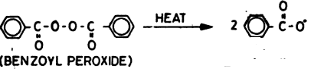

2. Azobis Isobutyro Nitrile (AIBN) Initiator( used around 50-70ºC)
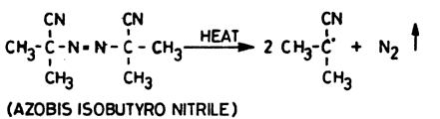

Step II - Propagation;

CIS + n (monomer) → Living polymer
R- M . + n M → R –(M)_{n} - M .

The growing chain the polymer is known as Living Polymer.

Step III - Termination;

3a) By Coupling : Radical + Radical → Macromolecule ( Dead polymer)

R- M . + . M – R → R – M – M - R

3b) By disproportionation by Hydrogen transformation:

Radical + Radical → Unsaturated polymer + Saturated polymer

The product of addition polymerization is known as Dead polymers.

EXPLANATION OF FREE RADICAL MECHANISM (eg) PVC polymerisation
1. Initiation

a) Initiator → Radical

1.The substance which undergoes homolytic cleavage to form radical is called ‘Initiator’. (e.g) acetyl peroxide initiator

2.The substance with single electron is called ‘ radical’. It is represented as R.
(e.g) acetyl peroxide radical

e.g Acetyl peroxide → Radicals ( at 80⁰C)
CH₃COO - CH₃COO → 2 CH₃COO .

b) Radical + Monomer → Chain Initiating Species (CIS)
H H
│ │
R. + CH₂=C → R – CH₂ - C.
│ │
Cl Cl

2. Propagation:

CIS + n (monomer) → Living polymer
H H H H
│ │ │ │
R – CH₂ - C∙ + n ( CH₂ = C ) → R (-CH₂ – C -)_{n}-CH₂ - C.
│ │ │ │
Cl Cl Cl Cl

3. Termination
a) Coupling

CIS /Radical + CIS / Radical → Macromolecule ( Dead polymer)

H H H H
│ │ │ │
R – CH₂ - C∙ + R- CH₂ – C. → R – CH₂ – C – C – CH₂ – R
│ │ │ │
Cl Cl Cl Cl
(Dead polymer)
b) Disproportionation (by Hydrogen transformation)

C is / Radical + CIS / Radical → Unsaturated polymer + Saturated polymer
H H H H
│ │ │ │
R – CH₂ - C∙ + R- CH₂ – C. → R – CH = C + H– C – CH₂ – R
│ │ │ │
Cl Cl Cl Cl
The products are known as dead polymers.

1.5-B)MECHANISM OF ANIONIC ADDITION POLYMERISATION :

When the chain reaction is initiated and carried by negatively charged (carbanion) intermediates, the reaction is known as anionic polymerization.

Monomers with electronegative groups like Cl⁻ , CN⁻ follow this mechanism.

Lewis bases like KNH₂ , NaNH₂ are used as initiators.

Eg. Vinyl chloride, Acrylonitrile polymerisation

3 steps are involved in Anionic mechanism:

1. Initiation
2. Propagation
3. Termination

Step I - Initiation :

Anion from lewis base + monomer → Chain Initiating Carbanion (CIC)

- + M → A - M⁻

Step II - Propagation;

CIC + n (monomer) → Living polymer

A- M ⁻ + n M → A –(M)_{n} - M –

The growing chain the polymer is known as Living Polymer.

Step III - Termination;

Living Polymer + Proton Medium → Dead Polymer + Anion

EXPLANATION OF ANIONIC POLYMERISATION (eg) Acrylonitrile

1.Initiation:

Here, Chain Initiating carbanion formation is taking place.

KNH₂ → K⁺ + NH₂—

H H
│ │
NH₂—+ CH₂=C → NH₂ – CH₂ - C⁻
│ │
CN CN (Chain Initiating Carbanion)

2. Propagation:
Here, the growth of the carbanion takes place. It involves the transfer of negative charge along the chain.
H H H H
│ │ │ │
NH₂ – CH₂ - C⁻ + n ( CH₂ = C ) → NH₂(-CH₂ – C -)_{n}-CH₂ - C⁻
│ │ │ │
CN CN CN CN
3. Termination:
The chain reaction is terminated when the carbanion reacts with the medium such as Ammonia, water etc,m
H H H H
│ │ │ │
NH₂(-CH₂ – C -)_{n}-CH₂ - C⁻ + H⁺NH₂⁻ → NH₂ –(CH₂ – C -)_{n}-CH₂-C + NH₂⁺
│ │ │ │
CN CN CN CN

1.5-C) MECHANISM OF CATIONIC ADDITION POLYMERISATION :

When the chain reaction is initiated and carried by positively charged (carbocation) intermediates, the reaction is known as anionic polymerization.

Monomers with electropositive groups like CH₃, C₆H₅ follow this mechanism.

The lewis acids like AlCl₃, BF₃, TiCl₄ are generally acting as initiators.

Examples: Isoprene, Styrene

3 steps are involved in Cationic mechanism:
1. Initiation
2. Propagation
3. Termination

Step I - Initiation :

Cation from lewis acid + monomer → Chain Initiating Carbocation (or)
Carbonium ion (CIC)
H⁺ + M → H – M⁺

Step II - Propagation:

CIC + n (monomer) → Living polymer
H- M⁺ + n M → H –(M)_{n} - M ⁺

The growing chain the polymer is known as Living Polymer.

Step III - Termination;

Living Polymer → Dead Polymer + Lewis acid

EXPLANATION OF CATIONIC POLYMERISATION. (eg) Polystyrene

1.Initiation:

Here, Chain Initiating carbonium ion formation is taking place.

AlCl₃ + H₂O → H⁺AlCl₃OH⁻

H H
│ │
H⁺AlCl₃OH + CH₂=C → H – CH₂ - C ⁺ AlCl₃OH⁻
│ │
C₆H₅ C₆H₅ (Chain Initiating Carbanion)
2.Propagation:
Here, the growth of the carbonium ion takes place. It involves the transfer of positive charge along the chain. It produces living polymer.
H H H H
│ │ │ │
H –CH₂ - C⁺ AlCl₃OH⁻ + n ( CH₂ = C ) → H(-CH₂ – C -)_{n}-CH₂ - C⁺ AlCl₃OH⁻
│ │ │ │
C₆H₅ C₆H₅ C₆H₅ C₆H₅
(Chain Initiating Carbanion) (monomers) Living Polymer

3.Termination:
When the catalyst is splitting from Living polymer , it results in Dead polymer product.
H H H H
│ │ │ │
H(-CH₂ – C -)_{n}-CH₂ - C⁺ AlCl₃OH⁻⁻ →H –(CH₂ – C -)_{n}-CH= C + H⁺AlCl₃OH⁻
│ │ │ │
C₆H₅ C₆H₅ C₆H₅ C₆H₅
Living Polymer Product + Lewis acid catalyst

1.6 ) GLASS TRANSITION TEMPERATURE (Tg)

Definition:

Glass transition temperature is the temperature at which a polymer abruptly transforms from the glassy (hard) to the rubbery state (soft). T_{g} for a linear polymer is sharp. A cross linked polymer does not possess any T_{g.}

Polystyrene (T_{g}= 100ºC) & PVC (T_{g}= 80ºC) are hard and stiff at room temperature.

Polyethylene (T_{g}= -105ºC) & polyethyl acrylate (T_{g}= -70ºC) are soft and rubbery at room temperature.
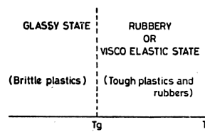
Factors influencing Tg Value:
1. Cross linkage: If the polymer chain is flexible in nature, its _{g} will be low. But cross linkages, aromatic rings, bulkier groups present in a polymer chain lowers the free movement, flexibility and increases T_{g}.
2. Crystallinity:. Higher the crystallinity, larger is the T_{g} value of a polymer.

3. Molecular mass: Generally T_{g} of a polymer increases with molar mass upto a particular value and beyond that there is no change.
4. Tacticity: Due to regular arrangement of functional groups, isotactic polymers have higher T_{g} than syndiotactic and atactic polymers.
5. Presence of plasticizers: Addition of plasticizers reduces the T_{g} value; for example, addition of diisooctyl phthalate to PVC reduces its T_{g} from 80ºC to below room temperature.
Significance of glass transition temperature:
(i) T_{g} can be used to evaluate the flexibility of a polymer and predict its response to mechanical stress.
(ii) Coefficient of thermal expansion, heat capacity, refractive index, modulus of elasticity and electrical properties at T_{g} determine the usefulness of a polymer over a temperature range.
(iii)Polymeric materials are subjected to different processing operations such as moulding, calendring and extraction. Knowledge of T_{g} is useful in choosing appropriate temperature for such processing operations.

1.7) MOLECULAR WEIGHT OF POLYMERS & POLYDISPERSITY INDEX
1. NUMBER AVERAGE MOLECULAR WEIGHT(_{n})

It is the ratio of sum of molecular weights of individual molecules to the total number of molecules in the mixture.

It is obtained by measuring the colligative properties.

It is a good index of physical properties such as impact and tensile strength.

Consider, a polymer mixture contains

n₁ molecules are with molecular weight M₁
n₂ molecules are with molecular weight M₂
and so on .,
n_{i} molecules are with molecular weight M_{i} then,

_{n} = n₁M₁ + n₂M₂ + …..+ n_{i}M_{i}
n₁ + n₂ + ….. + n_{i}

_{n} = Σn_{i}M_{i} / Σ n_{i}

2. WEIGHT AVERAGE MOLECULAR WEIGHT (_{w})

It is the ratio of sum of molecular weights of individual molecules to the total weight of molecules in the mixture.
It is obtained by light scattering and ultra centrifugation techniques.

Consider, a polymer mixture contains

w₁ is the weight of polymer with molecular weight M₁
w₂ is the weight of polymer with molecular weight M₂
and so on .,
w_{i} molecules are with molecular weight M_{i,} Then,

_{w} = w₁ M₁ + w₂M₂+ …..+ w_{i i}M_{i}
w₁+ w₂+ ….. + w_{i}.

_{w} = Σw_{i}M_{i} / Σ w_{i}

But, number of moles n = w / M

So, w= nM

We can replace w₁ by n₁M₁ , w₂ by n₂M_{2 …..} w_{i} by n_{i}M_{i}

_{w} = n₁M_{1.} M₁ + n₂M₂ M₂+ …..+ n_{i}M_{i}M_{i}
n₁ M₁ + n₂ M₂ + ….. + n_{i}M_{i}.

_{n} = Σn_{i}M_{i} ² / Σ n_{i}M_{i}

.

3. POLYDISPERSITY INDEX (PDI)

The ratio of weigth average molecular weight _{w} to number average molecular weight _{n} is known as polydispersity index or distribution ratio.

Polydispersity index = _{w} / _{n}

For polydispersed system, _{w} > _{n}

For monodispersed system _{w} = _{n}

If a polymer contains molecules of same molecular weight, such system is known as monodispersed system. But it is unreal condition. Such possibility is available only in simple chemical compounds like water, alcohol etc.,

If a polymer contains molecules of different molecular weight, it is polydispersed system.

The deviation of ratio from the unity is taken as a measure of polydispersity of the polymer sample.

For all synthetic polymers, PDI is higher than 1.

Higher values of the ratio indicates greater polydispersity. It means all the molecules of the polymers will not have identical molecular weight.

1.8) TECHNIQUES OF POLYMERISATION

Definition:

Under the proper conditions of temperature, pressure and catalyst , the micro (Smaller) molecules are combining together to form a macro (big) molecule. This process is called Polymerisation.

Types of Polymerisation:

- If the polymerization involves only one phase throughout the process, it is called as Homogeneous polymerization.
(eg) Bulk polymerization, Solution polymerization

- If the polymerization involves more than one phase, it is known to be a heterogeneous polymerization.
(eg) Emulsion polymerization , Suspension polymerization.

1) BULK POLYMERISATION:

i)Process:
It is a homogeneous polymerization method.
This method is done in two stages, viz. pre and post polymerization stages.

Pre polymerization stage:
In a Bulk reactor vessel, the monomer is taken in the liquid state and a small quantity of initiator is dissolved in it. So the whole system is in a homogeneous phase. Initiation is done by thermally or photo chemically. The mixture is heated up to polymerization temperature with constant agitation.

Post polymerization stage:
Once the reaction starts, heating is stopped as the reaction is exothermic in nature. The steady temperature is maintained till reaction gets over. The polymer produced will be a pure one. It does not need any further purification.

ii)Reaction: Monomer (Liquid) + Initiaor → Polymer

iii)Advantages:
a) Free from impurities
b) The amount of initiator left behind in the reactor is very small.

iv)Disadvantages:
a) In this exothermic reaction temperature control is difficult.
b) Difficult to remove the traces of monomer and initiator.

v)Examples:
PVC , Polystyrene, PMMA can be prepared by this method.

2) SOLUTION POLYMERISATION

i)Process:
It is a homogeneous polymerization method.

The monomer and initiator are dissolved in a solvent to form a homogenous mixture and heated with constant stirring. After the reaction, the solvent is evaporated and polymer is isolated.

ii)Reaction: Monomer (In solvent) + Initiator → Polymer

iii)Advantages:
As the increase in viscosity is minimum, stirring and heat control are easy.

iv)Disadvantage:
a)Because of costly solvents, the technique is costly.
b) The solvent molecules may act as chain terminators . Hence high molecular mass polymers cannot be prepared by this method.
c) Removal of residual polymers is not easy.

v)Examples
PVC , polyethyle , N- vinylpurolidine, acrylic acid can be prepared by this method.

3) EMULSION POLYMERISATION

i)Process:

It is a heterogeneous polymerization method.

A water insoluble monomer is dispersed in the water to form an emulsion of the size 10⁻⁵ to 10⁻⁶ mm. The emulsion is stabilized by surfactants.Surfactants form micelle, lower the surface tension at monomer – water interface and facilitate the emulsification.

Beyond a particular concentration, the surfactants form molecular aggregates known as micelles .This concentration is known as Critical micelle concentration (CMC). If the quantity of added emulsifier is more than CMC, then only emulsion polymerization takes place. Otherwise, it results in suspension polymerization.

Initiators are added to diffuse the monomers from the monomer droplets. When the reaction proceeds, the micelles increase in size due to the formation of polymer. As the polymerization sites are isolated from each other, termination reactions are less likely to take place. So, high molecular weight can be obtained.

ii) Rxn: Monomer ( Water insoluble) + Water + Emulsifier + Initiator → Polymer

iii) Illustration:

For Polystyrene production, the set up needs the following:
S.No | Content | Example
1 | Monomer | Styrene
2 | Solvent | Water
3 | Initiator | K₂S₂O₈ Persulphate
4 | emulsifier | Sodium lauryl sulphate
5 | buffer | Phosphate

iv)Advantages:

a)No viscosity builds up and hence agitation is easy.
b)High molecular weight polymers can be produced.
c)Rapid production of polymer

v)Disadvantages:

As the polymer may contain emulsifier and surfactants as impurities , it needs further purification.

vi)Example: Polystyrene , PVC ,PVA, PolyMethylMethAcrylate (PMMA) can be prepared by this method.

4) SUSPENSION POLYMERISATION : (PEARL POLYMERISATION)

i)Process:

It is a heterogeneous polymerization method.

The water insoluble monomer is suspended in water solvent. Then it is agitated to form large monomer droplets of the size 0.1 – 1 mm. The droplets are prevented from coalescing by adding PVC or gelatin stabilisers.The initiator is added and heated around 60 º C with constant agitation for 8 hours.

Polymerisation takes place inside the tiny droplets and the product obtained as spherical beads or pearls. So it is also known as pearl polymerization. The unreacted monomer is recycled.

ii) Reaction:
Monomer ( Suspended in water) + Initiator ( Soluble only in monomer) → Polymer

iii)Illustration:

For Polystyrene production, the set up needs the following:
S.No | Content | Example
1 | Monomer | Styrene
2 | Solvent | Water
3 | Initiator | peroxide
4 | Stabiliser | gelatin, aluminium hydroxide
5 | Buffer ( Optional) | Phosphate

iv)Advantages:

a)Because of the water solvent, the process is cheap.
b)As the product is water insoluble, product isolation is easy.

v)Disadvantages:

a) The reaction is highly sensitive to agitation,
b) Particle size of polymers is difficult to control.

vi)Examples:
Polystyrene beads and styrene-divinyl benzene copolymer beads can be prepared by this method.

1.9) PREPARATION, PROPERTIES AND USES OF NYLON -6,6

Condensation Polymerisation of Hexa methylene diamine and Adipic acid results in polyamides.(eg) Nylon 6,6

Properties:
1.Flexibililty
2.Elasticity
3 Absorbs only little moisture
4. Translucent nature
5.High impact strength

Uses:
1. Tooth brush bristles
2.Automobile gears
3.Textile industry
4. Nylon ropes
5. Socks
6. Carpets

1.10) PREPARATION, PROPERTIES AND USES OF EPOXY RESINS

Bisphenol – A ( Diphenol propane) and epichloro hydrin combine together to form Epoxy resin. The reaction is carried out in basic medium.The value of n ranges from 1 to 20.
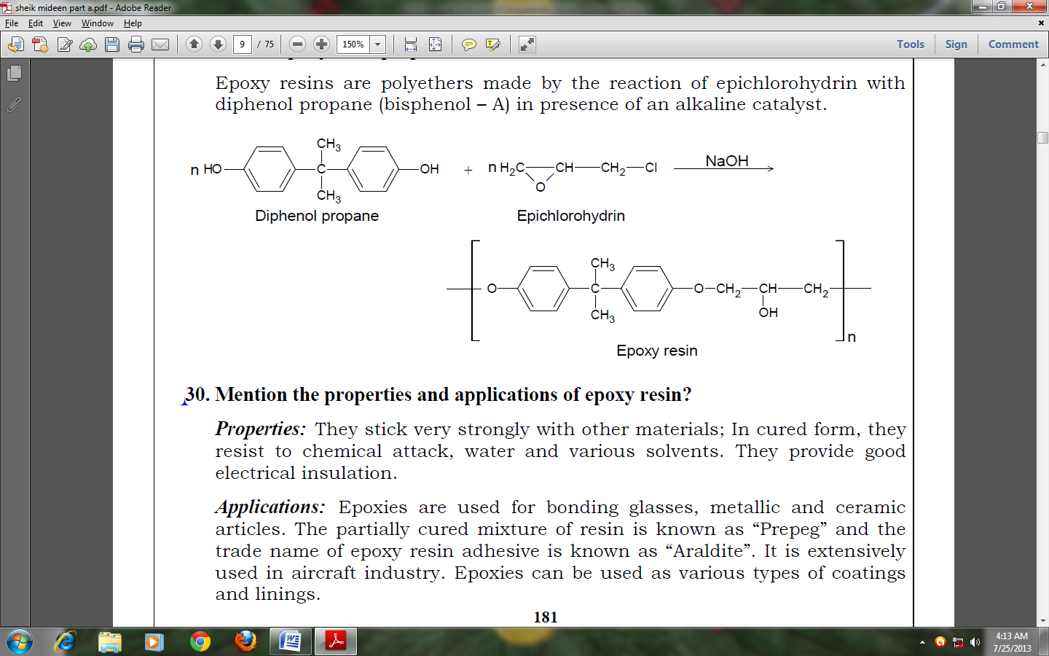
Properties:
i ) Adhesiveness
ii) Due to stable ether linkage, they resist to chemical attack, water, acids , alkalis
and various solvents.
iii) They provide good electrical insulation.

Applications:
1.Bonding glasses, metallic and ceramic articles.
2.The partially cured mixture of resin is known as “Prepeg” and the trade name of
epoxy resin adhesive is known as “Araldite”.
3. Used in aircraft industry, Fibre reinforced plastics etc.,
4.Used as various types of coatings and linings.
5. To give crease resistance and shrinkage control in textile industry.
6. Insulators for high voltage transmission lines.

